* **Basic and approach**

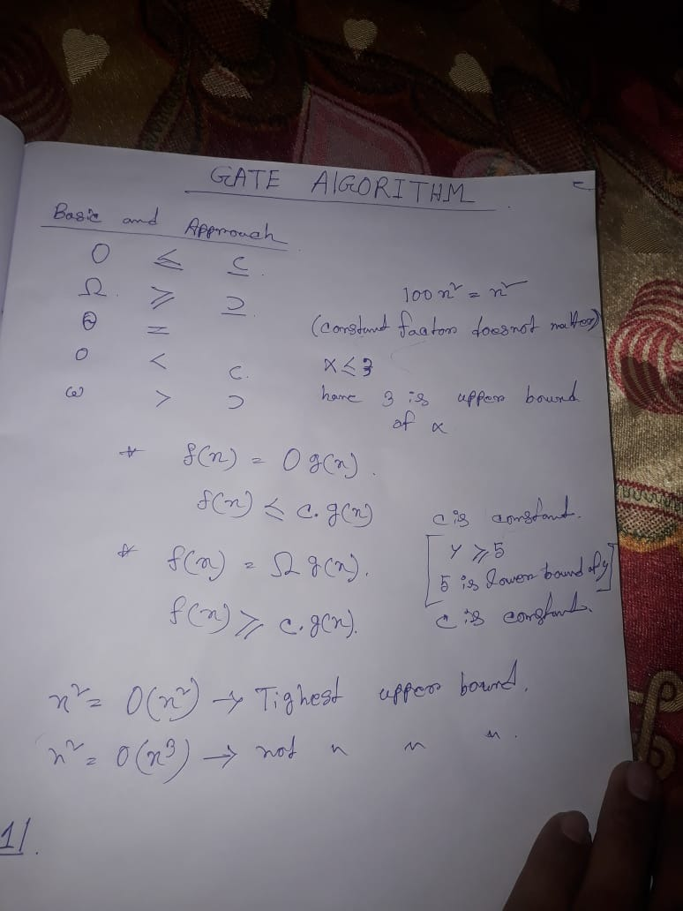

Constant<Linear<polynomial<exponential

100000< n < 2k < 2n [k is constant, n is linear value].

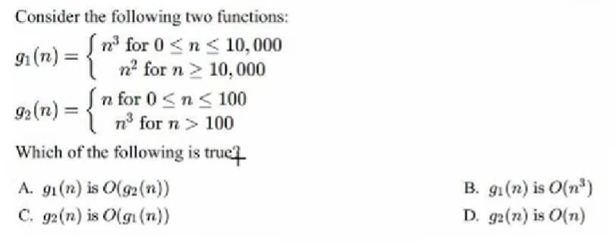

As we have to take upper value of n,

So, 



1. n2  <= n3 it is correct.
2. n <= n3 it is correct
3. n3 <= n2 it is false.
4. n3 <= n it is false.

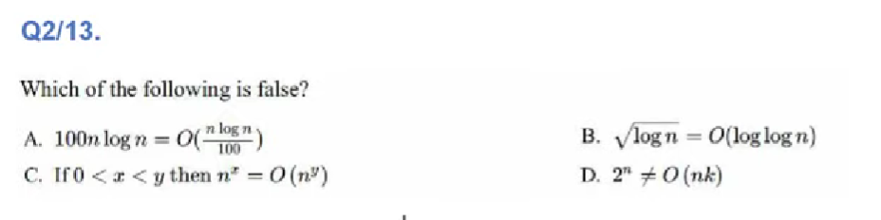

1. nlogn <= nlogn so it is true.

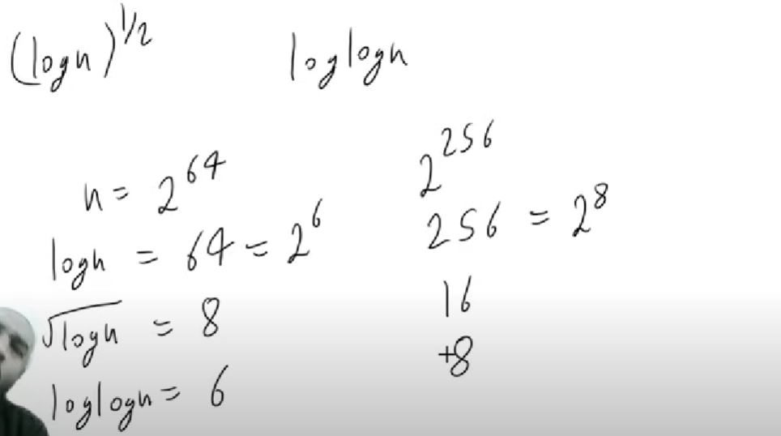

So , option B is false.

1. As y is greater than y, so it is also true.
2. Hare 2n is exponential but in nk , k is constant and n is linear,

So it is also true.

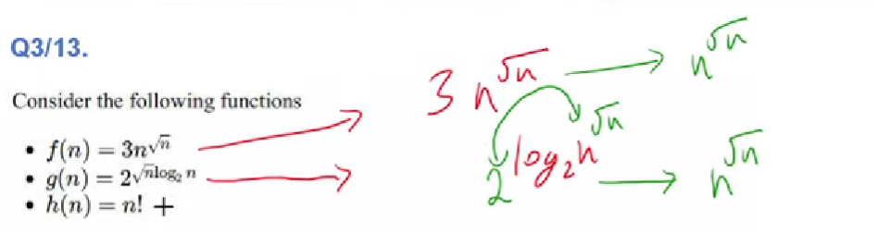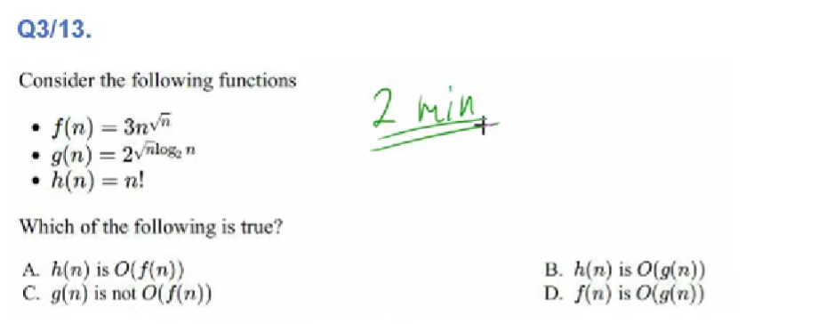

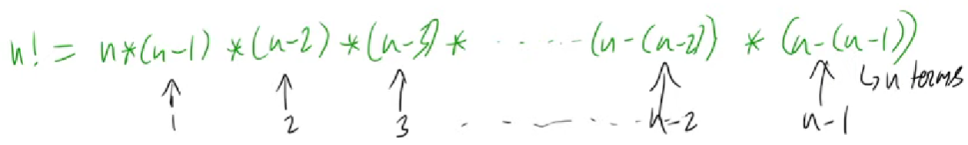

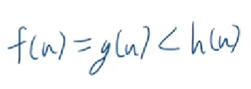

So, option D is only correct option.

**one important concept of taking log**

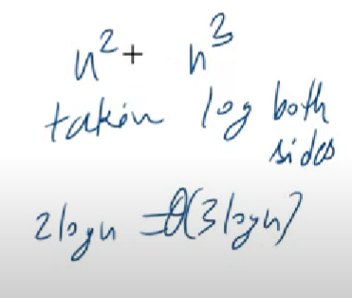 hare if I took log between them, it giving wrong ans.

Before taking log we should remove common part.



O(1) and O(n).

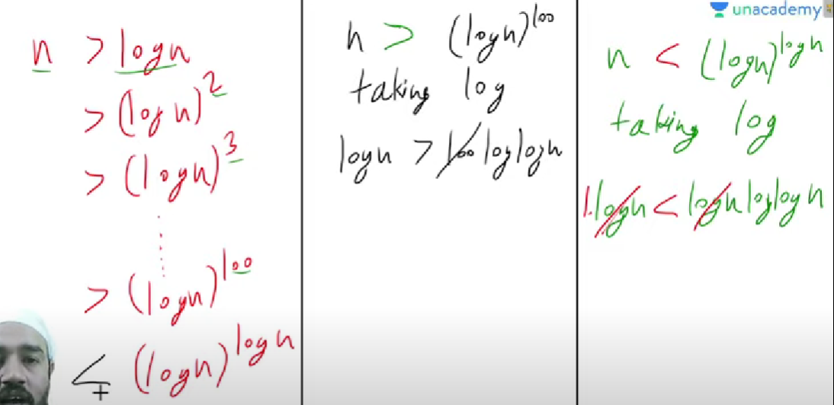

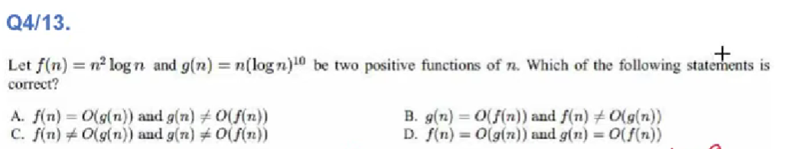

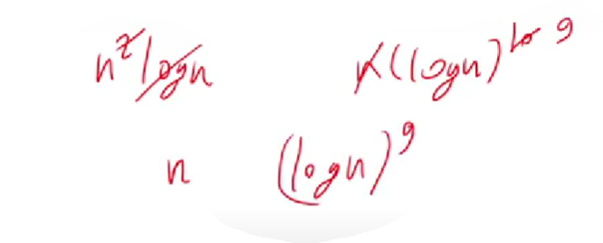

So, option B is correct.

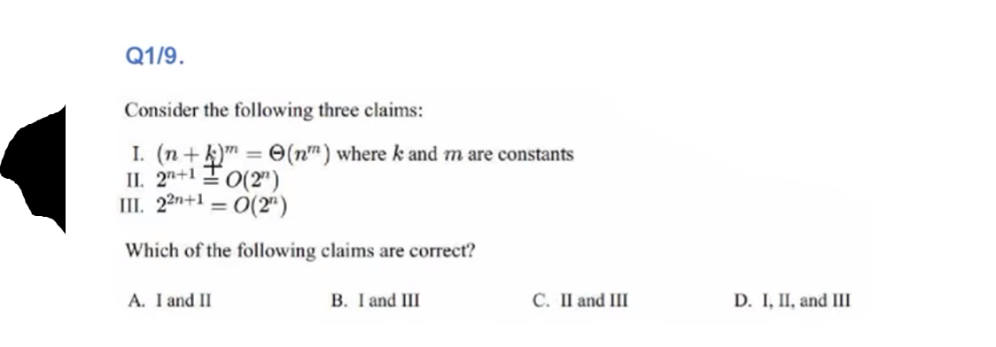

1. 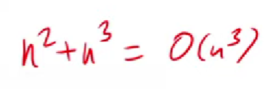(n+k)m = nm, so I is true.
2. 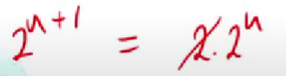 so II is also true.
3. 22n+1 = 2.(2n)2, so , III is false

Ans is A.

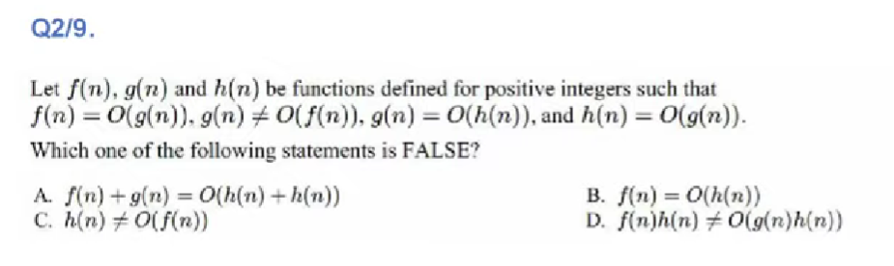

………………………………………………………………………….

f(n) = O(g(n)) 🡪 f(n) <= g(n)

g(n) != O(f(n)) 🡪 g(n) != f(n) and g(n) !< f(n)

……………………………………………………………………………

From this two we can get f(n) < g(n)

……………………………………………………………………………

g(n) = O(h(n) 🡪 g(n) <= h(n)

h(n) = O(g(n) 🡪 h(n) <= g(n)

…………………………………………………………………………..

From this two we can get g(n) = h(n)

1. f(n) + g(n) = O(h(n) + h(n))

* f(n)